Community Update
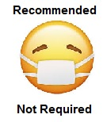 Currently, we no longer require wearing a mask to enter the building.
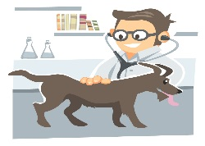We do encourage wearing a mask in smaller spaces such as the exam rooms during your pet’s appointment. We also request limiting the number of clients in the exam room to one pet parent unless necessary.
This Photo by Unknown Author is licensed under CC BY-SA
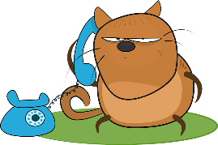We are still requesting clients call 973-539-2808 to check in and wait in the car, so we do not crowd the waiting room.
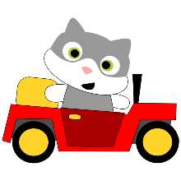A staff member will come outside or send you a text message when an exam room is available, and they are ready for you and your pet.
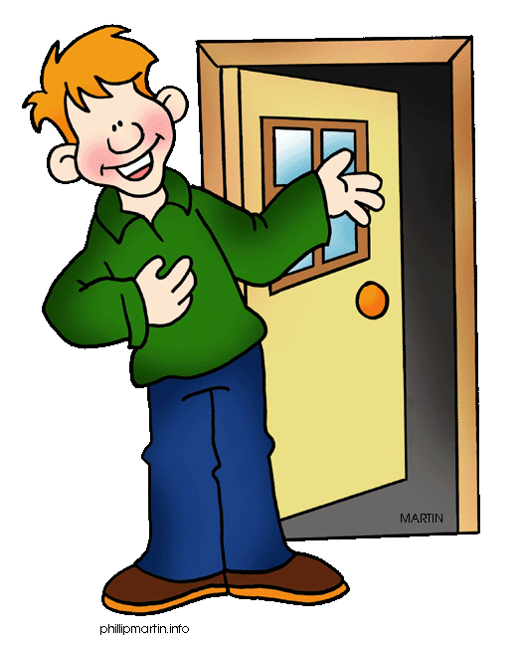You do not need to call in when you arrive to pick up medications or food. You can come into the lobby or retrieve them from the vestibule medicine cabinet if they have already been paid.
This Photo by Unknown Author is licensed under CC BY-SA-NC
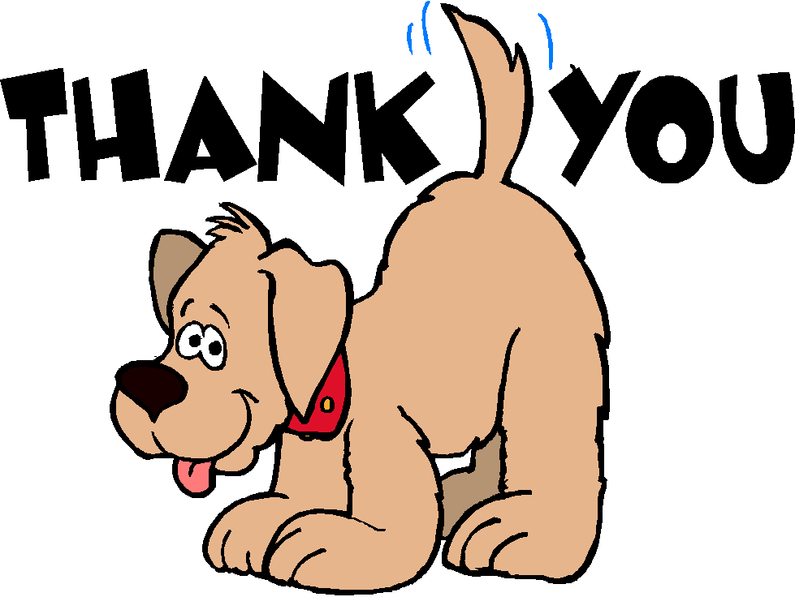We thank you for your understanding and patience as we continue navigating to keep our staff & clients healthy, safe & comfortable!
This Photo by Unknown Author is licensed under CC BY-NC-ND
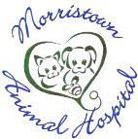 - The Doctors & Staff @ Morristown Animal Hospital

